Use Case Realisation Report - Manage ProjectPropose Project
FOR
Volunteer Management System
(VMS)

CLIENT
PROJECT | Volunteer Management System (VMS)
TITLE | Use Case Realisation Report - Manage Project
VERSION | 0.1a
DATE | 13-Aug-2011
 | ORIGINATOR
 | Name / Signature | Team 8S
 | APPROVAL
 | Name / Signature | Phung Kim Cuong, Dio
Institute of Systems Science |  | Document Reference
25 Heng Mui Keng Terrence  Singapore 119615 |  | VMS/PM-1.3.1/1

 | Acceptance
 | Customer Signature |  | Customer Signature
 | Name & Designation |  | Name & Designation
 | Date & Company Stamp |  | Date & Company Stamp

Revision History

Date | Version | Description | Author
12-Jun-2011 | 0.1a | Creation | Team 8S
 |  | Refer to amendment history

Table of Contents

1. Brief Description 3
2. Flow of Events 3
2.1 Standard Flow 3
2.2 Exceptions 3
3. Interaction Diagrams 4
3.1 Domain Collaboration Diagram: Propose Project 4
4. Participating Objects 4
5. Derived Requirements 4
6. Derived Requirements 4
ANNEX D Amendment History 4

Use-Case Realization Report
Propose Project

Brief Description
The use case enables registered user to propose new project.

Flow of Events
The standard flow of events for this use case and any exceptions are described in the following subsections. See section 3.1 for an overview of the participating Actors and Domain Objects.

Standard Flow

Precondition: User has logged in the system

This use case provides the user interface related functionality that will be provided to the User, as follows:
- The Volunteer clicks ‘ProposeNewProject’ button on the ProjectListingScreen and the system is redirected to ProposePojectScreen.
- The project proposal form will be displayed on the ProposePojectScreen, including the following fields:
- Project Name
- Project Description
- Country
- Location
- Estimated Duration
- Proposer
- The Volunteer can also upload the supporting documents on the screen
- When the user click ‘Submit’, the proposeProject() method of projectController will be triggered to create a new project proposal
- The projectController will use the validateProjectProposal() to perform business validation of user input information.
- After validation, the create() method of ProjectProposal object is triggered to create a new object in the database
- The displayMsg() of ProposeProjectScreen is used to display an success message to Actor
- The screen will be finally redirected to ProjectListingScreen.

Exceptions
The following exceptions have been identified:
- Invalid Information Format. If any of input info is incompatible, system will give a validation summary for user to make corrections

Interaction Diagrams

Domain Collaboration Diagram: Propose Project
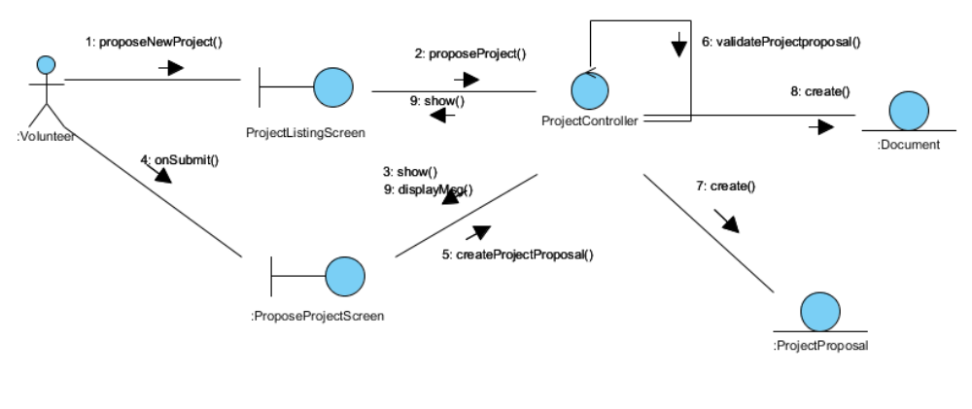

Participating Objects
:
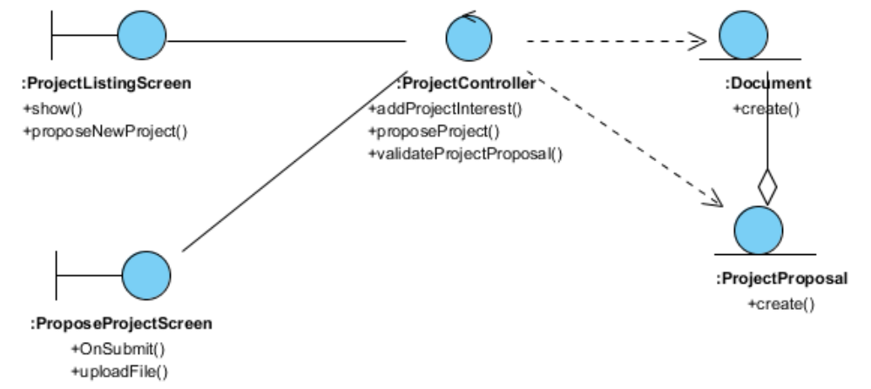

Derived Requirements

:

Derived Requirements

ANNEX D Amendment History

This is a record of all amendments made to the Document.
Version | Chapter / Section | Page No | Notes of Amendments or Changes

